1- Introduction
Understanding how ecological communities are organized across space scales is a long-standing
question in community ecology with a well-established conceptual framework ((Decaëns, 2010); (Azaele et al., 2015)). In theses works, authors highlight the importance of considering the spatial scale in analysis. Thus, spatial scale is the targeted area where samplings are done. In this area, multiple spatial processes are played out, creating unique biodiversity patterns. Moreover, theses process are possible thanks to filtering, that is to say, environmental influences that limits biodiversity(Hutchinson, 1957). Similarly, biologic interactions within species tends to limit biodiversity as major part of them constrains individual. However, understanding the relative part of spatial process, environmental filtering and biotic interactions in multi-trophic community assemblage still deserve much works. The importance of holding area constant in analysis has been accentuated, as is the notion that different environmental factors exhibit measurable heterogeneity at different scales (Wells et al., 1999) proposed and (Whittaker et al., 2001). In other words, the ecological filters do not affect the diversity with the same intensity (Whittaker et al., 2001),(Chase et al., 2019). It’s important to identify how species richness change across spatial scale and what are the main drivers of these changes (Chase et al., 2019) to guide preservation and protection of biodiversity (Whittaker et al., 2001).
A large amount of metrics are available to estimate biodiversity (Pulleman et al., 2012) ; (Konopiński, 2020) ; (Tuomisto, 2010). Most metrics also have advantages, drawbacks, and habitat or scales preferences (Pulleman et al., 2012; Dopheide et al., 2020; Willis, 2019). α-diversity informs about a single and target location. β-diversity refers to compositional changes between samples.
α-, β- and γ-diversity are under the influence of many factors, such as geographic distance, environmental variables or biotic interactions (Rodriguez-Artigas et al., 2016). The β-biodiversity is not equally influenced across spatial scale (Steiner & Leibold, 2004). This is why, (Ferrier et al., 2007) explained how to study β- diversity with a global dissimilarity model. In order to understand how spatial scale described α-diversity, (Joseph, 2002) showed the additive partitioning model, in adequation with null model which create a pattern where diversity is only explained by randomness.
While many studies focused on aboveground communities and their dynamics through time and space, the belowground part of the ecosystems still remain poorly studied (Vaněk, 1975); (Nielsen et al., 2010). The soil hosts a huge amount of diversity, as well as it contains many terrestrial fauna families (Gongalsky, 2021), We only know at best a tiny fraction of the existing species diversity, and our knowledge of both the distribution and abundance of many known species remains very poor (Wilson & Barker, 2019); (Decaëns, 2010); (Turner, 2021). In addition, soil organisms are involved in ecosystems functioning and biogeochemical cycles, putting compounds into movement, accelerating decomposition and mineralization (Bradford et al., 2002); (Lal et al., 2015)
In rhis context, mountains ecosystem represents a unique matrix, where soils are diverse in composition, structure and thus, biodiversity hosted. In this logic, it might be interesting to invest mountain biodiversity patterns in order to better know theses ecosystems.
Several researches have used elevation gradient to highlight the factor structuring soil fauna (Fischer et al., 2011).; (Peters et al., 2016); (Yin et al., 2017). These researches are focusing on elevation gradient as a synthesis a lot of directs and indirect factors, such as pH, temperature, water deficit, incident light. The number of variables involved in an altitudinal gradient makes this system very unique (Körner, 2007). Elevation gradients exhibit complex variation in abiotic conditions over short distances (McCain & Colwell, 2011). It is known that biodiversity tends to decrease as elevation increases, because of shelter function t low elevation (Keppel et al., 2017) and harshness of the environment at high elevation (Fischer et al., 2011)In order to understand how species are distributed in space, it is also relevant to depict the relative role of ecological gradients (Perrigo et al., 2020).
Soil (macro)fauna (between 1mm and 5 cm) is very diverse and includes many animal families (Gongalsky, 2021), leading to complex and different interactions between organisms themselves and with abiotic parameters (Fischer et al., 2011) (Perrigo et al., 2020). Recently, (Calderón Sanou, 2022) found that along elevation gradients, the driving factors differ across trophic guilds revealing the relative weight of four main mecanisms (Habitat heterogeneity, Energy, Abiotic Tolerance and Resource Heterogeneity). Habitat heterogeneity represents soil structure, Energy represents the amount to energy that the ecosystem receive, Abiotic Tolerance represents the physiological stress that organisms experiment (PS) , and Resource Heterogeneity the diversity in resources available for organisms.
Following (Calderón Sanou, 2022), we focused on macrofauna (not studied in their work) (1) to depict soil macrofauna biodiversity patterns at various nested scales from soil sample to mountain range and (2) to elucidate the relative role of geographic distance, ecological filtering and biotic interactions.
The first hypothesis is, that larger spatial scale should explain more diversity than smaller scales, as supported by (Pyron & Wiens, 2013),(Qian & Ricklefs, 2007).
The second assumption states that, geographic distance is the main factor driving communities at larger spatial scales. In other terms, colonization abilities and biogeography should be the principal obstacles in organism spreading, as (Drake, 1990)already supported. In addition at intermediate scale, we suspect a role of habitat variable, like the vegetation opening or climate influence (Beaugrand, 2023). At a lower spatial scale, biologic interctions such as vegetation composition, predations, competitions should drive communities β-diversity (Calderón Sanou, 2022).
Finally, we make the assumptions that factors influencing every trophic guild are not totally the same, because each trophic guild respond to their own pressure factors (Calderón Sanou, 2022).

2- Material and Methods
2.1. Sampling sites
All the sampling sites are being monitored by Orchamp Observatory (https://orchamp.osug.fr). The 11 studied altitudinal gradients were located in the Alps and the Pyrenees mountains, both in their French part : Argentière (Chamonix Mont-Blanc - 45.985496, 6.947277), Armenaz (Ecole – 45.625926, 6.228909), Cauterets (Cauterets – 42.831, 0.174), Chaillol (Chaillol – 44.721, 6.187555), Forêt du Bout (Pinsot – 45.324, 6.107), Lac Vert/Vallée du Lys (Saint Mamet - 42.72073, 0.5675), Mounier (Beuil – 44.142, 6.983), Pécloz (Ecole – 45.638226, 6.217314), Ristolas (Ristolas – 44.724622, 7.031392), Saint-Barthélémy (Montségur – 42.838705, 1.797797), Tania (Courchevel – 45.414, 6.601), Valloire (Valloire – 45.126224, 6.397591), and Ventoux Nord (Beaumont du Ventoux – 44.177, 5.251). Samplings have been realized in 2021 and 2022 during early Automn (September to October).
2.2. Plots

The permanent plots measure 900 m², and are spaced from each other by a minimum altitude of 200 m, for every gradient. The lowest starts at 1130 m (Ventoux Nord), and the highest one is placed at 2940 m (Chaillol). In average, four plots are placed in every gradient. Every plot has the same orientation, has a homogeneous topography, don’t include water stream, are far from paths but can include pasture.

2.3. Sampling methods
As every organism isn’t present at the same depth of the soil, don’t have the same physical niche, and the same moving pattern, we need to use multiple methods to capture them.

Pitfall traps
In every plot, six pitfall traps have been placed 15 m apart in two lines at the edges of the permanent plot. A pitfall trap was made of a 125 ml plastic pot, buried up to its superior border and filled with about 40 ml of vinegar over saturated in salt. This solution killed organisms, avoided consumption and conserved individuals. To limit additional organic matter and water filling by rain, a cap was placed 5 cm over the pot. The traps were collected 1 month after their setting. Back at the laboratory, organisms were desalted into tap water during two days and then stored in 98° alcohol.

Soil hand sorting
In every plot, four soil monoliths were excavated outside the corners of the permanent plot. Before digging, vegetation was removed and animals in plant litter were hand sorted. Soil blocks were 25 x 25 cm in surface and up to 20 cm in depth. Then, macrofauna was hand sorted from soil blocks and stored in 98° alcohol.

2.4. Identification
Lumbricinae, Carabidae, Isopoda and Diplopoda, part of Araneae, part of Myriapoda have been identified precisely to species (or at least to genus) by specialists in laboratory (See Acknowledgements part). For this, the identification keys used were Lumbicinae (Bouché, 1972): Araneae :(Nentwig et al., 2014) Isopoda :(Vandel, 1960) Carabidae :(Coulon & Pupier, 2011), (Jeannel, 1942), Myriapoda :(Demange, 1981) (Brolemann, 1930)
Among all the individual sampled during sampling campain, 60% have been identified in laboratory.. The other individuals (the remaining 40% of individuals) have been proposed for identification by citizen science through to the web-application Inaturalist. All observations can be found here: https://www.inaturalist.org/projects/orchamp_global
Individuals were grouped by morphotypes in each sample. On average two pictures, namely dorsal and ventral view, have been taken for each morphotype. Photographs of small organisms are obtained under binocular magnifier equipped with a 20MP USB3.0 CMOS Camera. The software Capture V2.4 stacks a live video at different focal distances to get a stacked photo. Larger organisms are placed under a Panasonic Lumix 25-600 at ~30 cm from the device.
A unique ID was attributed to each individual that has been photographed. Then photographs were posted on Inaturalist, with metadata (spatial coordinates, date of sampling) and a proposed identification that was then challenged and improved by INaturalist participants. The present dataset corresponds to an extraction from INaturalist the 02/06/2023 that has been merged to identification matrix obtained from the Eco&Sols lab thanks to the unique ID attributed to each photographs.
2.5. Trophic Guilds creation
In order to create trophic guilds, we looked after the species database composition. We decided to group Chrysomelidae family and Orthoptera order together as representatives of Herbivores group or green chain. We associated with this group the “Pitfall Trap” method, because it’s mostly species that walk on the ground. Predators group is composed by Carabidae family. The “Pitfall Trap” is also chosen. Detritivores were represented by Clitellata and Diplopoda class, Isopoda order. As they belong to underground organisms, we selected the soil hand sorting method. Finally, parasitoid trophic guild are composed by all the Hymenoptera we gathered, except the Formicidae family. They can be captured thanks to the “pitfall trap” method (Brown & Matthews, 2016).
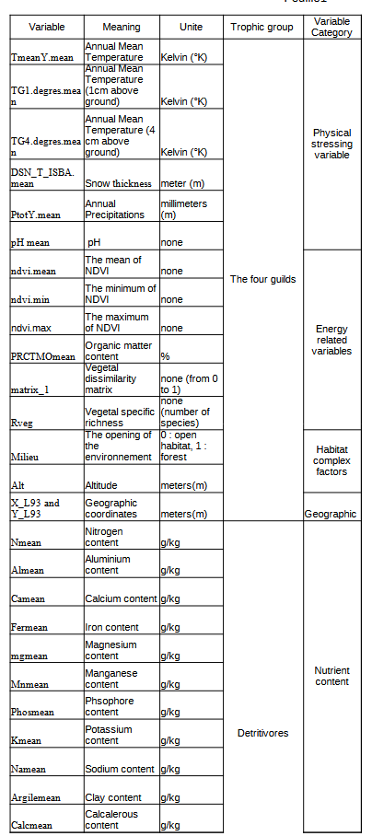Tableau 1: Variables elected for Global Dissimilarity Modeling, with heir meaning, unite, supposed guild influences and categorie belonging

2.6. Environmental data
The selection of variables groups has been done regarding (Calderón Sanou, 2022). Physical Stressing variables come from Physical Tolerance Hypothesis, Variables related to energy are inspired from Energy Hypothesis, and Resource Heterogeneity Hypothesis. Complex Driving factor (Altitude and Opening of Habitat) and Geographic factor have been added, from my own choice, in order to observe the potential hidden effect of these kind of variables (Fischer et al., 2011), and to test dispersal hypothesis. Then, we created the dissimilarity matrix for plant species (matrix_1, biotic variable) to compare with main community matrix, also with vegdist. The distance used was Bray-Curtis distance.
For Detritivores, we added a pool of variables, in line with (Tiunov & Scheu, 2004), (Curry & Schmidt, 2007). We decided not to include Habitat heterogeneity group elsewhere than in Detritivores groups, because it’s composed of soil characteristics, less important for other trophic guilds (Calderón Sanou, 2022). The variables used for analysis, for all the groups can be found in tableau1.
For every computed GDM, I have tested the significance of predictors by cross validation (function gdm.crossvalidation). Unfortunately, the significance is not presented here, by a lack of space.

2.7. Scales of analysis
Spatial scales of study targeted for the Additive Diversity Partitioning was between sample (β1 : dissimilarity between samples), between plot (β2 : Dissimilarity between permanent plots), between gradients (β3 : Dissimilarity between elevation gradients).

2.8. Statistical analysis
2.8.1. Additive Species Diversity Partitioning
We performed an additive partitioning of species diversity to quantify differences in species composition at various nested spatial scales: the sample scale (~10⁰ m²), plot scale (~10³ m²), elevation gradient scale (~10⁶ m²). Mean values of species diversity at lower spatial scale (α diversity, sample) of a sampling hierarchy (β diversity between plots and gradients) are compared to the total diversity in the entire data set (γ diversity, Northern Alps+Southern Alps+Pyrénnées). β1 is the compositional diversity between samples, that is to say, between pit traps, or between monoliths of soils. β2 is the compositional diversity between permanent plots and β3 is the compositional diversity between elevation gradients. At the highest sampling level, the diversity components are calculated as β_m = γ – α_m. For each lower sampling level as β_i = α_(i+1) – α_i. Then, the additive partition of diversity is γ = α_1 + sum(β_i). In tableau 1, you can find shannon gamma diversity for every four trophic guild.
Tableau 1: Gamma diversity for the four trophic guilds
We used the function adipart() from the vegan package. We used Shannon diversity to evaluate diversity. We specified the argument ‘prop’ for weighting diversity index by abundance, and performed 150 permutations.
Here is the Shannon Diversity Index Formula : 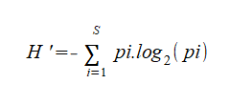
Where pi the proportional abundance of a species, si : the number of individuals for a species, N : total number of individuals, and S : the number of species.

2.8.2. Gobal Dissimilarity Model (GDM)
The Global Dissimilarity Model analyses beta biodiversity patterns. Here, it allows us to identify the main predictors influencing β diversity, by relating compositional dissimilarity between sites to how much sites differ in their environmental conditions (environmental distance) and how isolated they are from one another (geographical distance). For the each trophic guilds, we created dissimilarity matrices between samples (β1), between plots (β2) and between gradients (β3) using the function vegdist() from the package vegan, Bray-Curtis distance. We compared the magnitude of effects of the predictors between trophic guilds at each spatial scale. Predictors associated-coefficient don’t have any unite
2.8.3. Fitted relationships between Predicted Ecological Distance and Observed Dissimilarity (Fitted splines)
This relationship allows us to observe trophic guild response to ecological gradient. It have been done thanks to the GDM package. The correlation plot is automatically calculated when we perform the gdm() function on the pairewise matrix previously created. “The predicted ecological distance η (is) derived as the sum across all predictor variables of the absolute differences in the model transformed predictor values (...) between sites”(Mokany et al., 2022). The Observed Dissimilarity is calculed when we previously created the paiwise matrix.
All the analyses were performed on RStudio version 4.2.3.1. Scripts, data and figures are available at https://github.com/Aurelien-Navarro/Macrofauna
3- Results

3.1. Species diversity partitioning
Species diversity was mostly explained by compositional difference (20-30%%) at larger scale : β3 between elevation gradients) for predators and detritivores. Herbivore diversity is mostly explained between plots (20%).
Parasitoids diversity is shared equally between plot and between gradients.
Shannon diversity only accounts for 10% to 15% of explanation between samples. In general, across all scales, Herbivores respond differently. Detritivore diversity explained by alpha is quite poor (10%) in comparison with herbivore diversity (20%).

3.2. Predictors of β-diversity
Between samples (β1), the variables related to energetic constraints are the most important drivers, followed by variables reflecting physical stress (figure 2). Geographical distance affected changes in herbivores, predators and parasitoids species composition, but not that of detritivores.
Between plots (β2), physical stressing variables explain most of the dissimilarity (relative coefficient = 3). Energy related variables (E) are also good predictors, except for detritivore, where Nutrient Content (NC) is important. Complex variables (CF) such as the opening of habitat and Altitude have light relative coefficient, as the geographic factor. Theses two categories don’t affect detritivores dissimilarity.
Between gradients (β3), almost all predictors influencing beta diversity belong to physical stressing category. Energy associated variable (NDVI) only influencing predators guild. The opening of habitat have a light coefficient (0,5 in average) for herbivores and parasitoids. Detritivores dissimilarity is also caused by a Habitat Heterogeneity (HH) : Coarse silt content, with a relative coefficient of 0,5.
Predictors coefficients are the lighters between gradients.

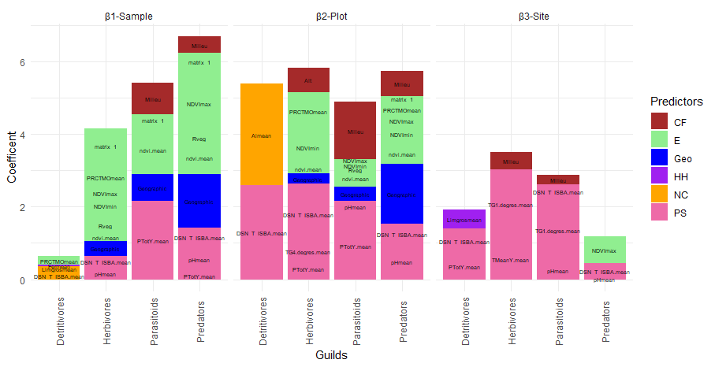Figure 2: Barplot of the relative contribution of predictors to beta diversity in three scales and for four trophic guilds
3.3. Diversity - distance decay relationships
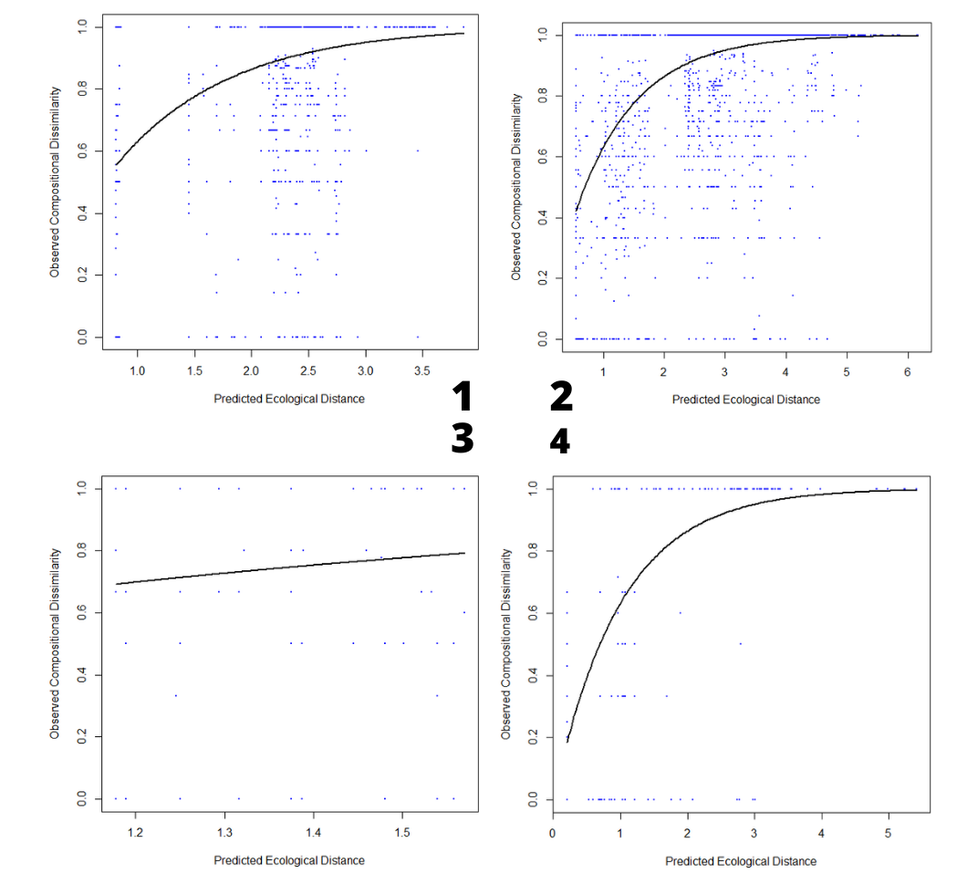Figure 3: Fitted relationship between predicted ecological distance and observed compositional dissimilarity for 1) Herbivores, 2) Predators, 3) Detritivores, 4) Parasitoids, between samples (local-β1).
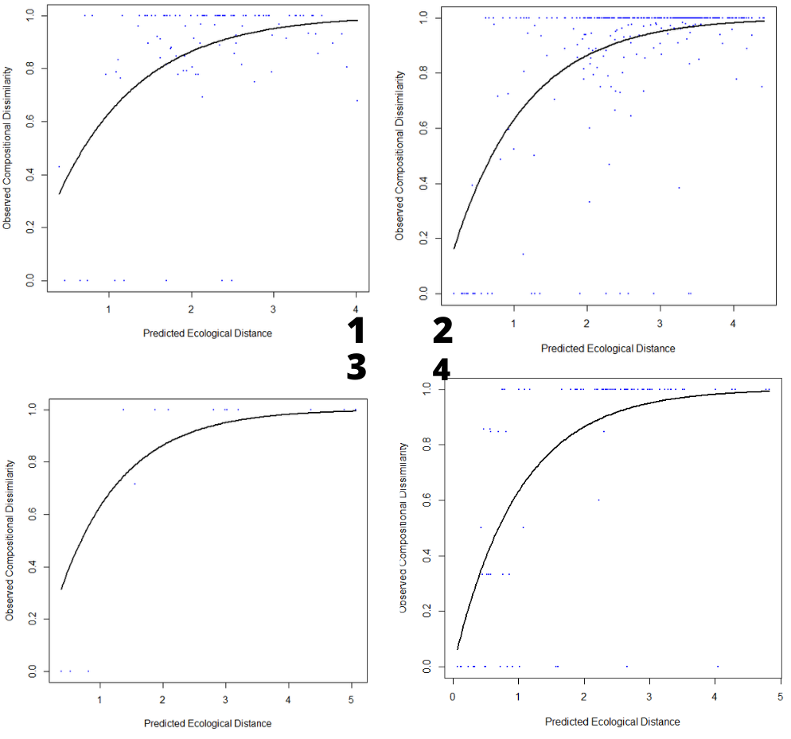Figure 2: Fitted relationship between predicted ecological distance and observed compositional dissimilarity for 1) Herbivores, 2) Predators, 3) Detritivores, 4) Parasitoids, between plots -β2.
Between samples, maximum dissimilarity in species composition of herbivores, parasitoids and predators was observed for an Ecological Distance of 3.5, 5.0 and 6.0, respectively (figure 3). Relations between herbivore and detritivores β1-diversity and Ecological Distance were similar, with a minimum dissimilarity of 0.6, differing from those of predators and parasitoids that exhibited a minimum dissimilarity of 0.2

Between plot, herbivores and predators are reaching a maximum dissimilarity for an Ecological Distance of 4. The minimum dissimilarity is reached at 0.35 (herbivores) and 0,3 (predators and detritivores) for an ecological distance of 0.

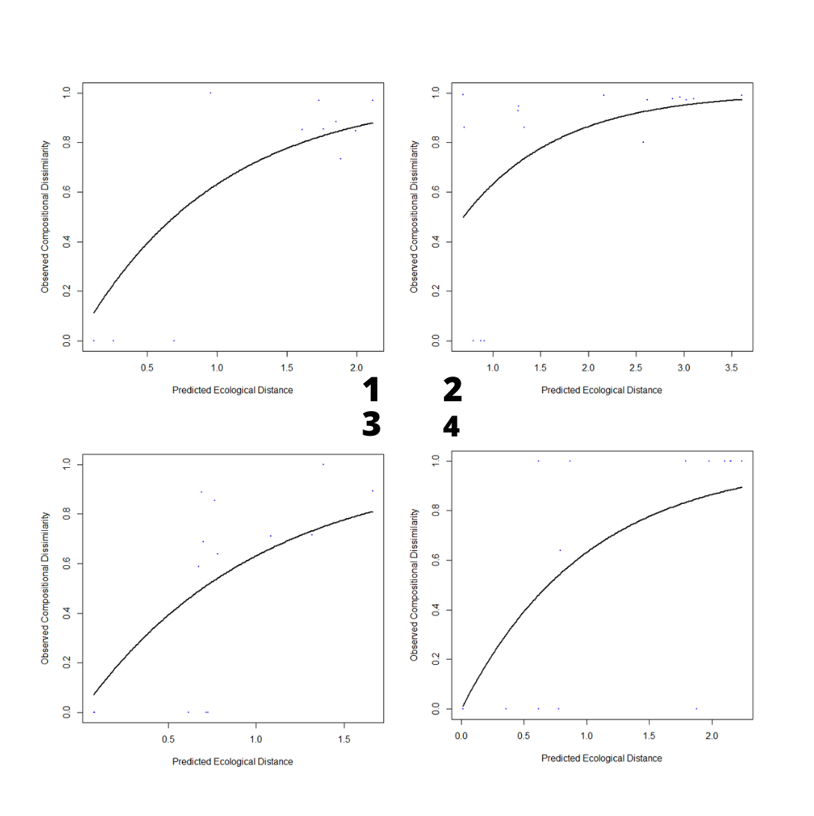Figure 5: Fitted relationship between predicted ecological distance and observed compositional dissimilarity for 1) Herbivores, 2) Predators, 3) Detritivores, 4) Parasitoids, between gradient (global-β3).
Detritivores curve is linear, with a maximum dissimilarity of 0,4, reached for an Ecological Distance of 0,3. (figure4)
Parasitoids and detritivores reach their maximum dissimilarity of 1 for a distance of 5. Parasitoids dissimilarity at an ecological distance of 0 is almost 0 (0,05).
Between gradients, herbivores predators and parasitoids dissimilarity correlations are similar, with a maximum dissimilarity reached for an Ecological Distance of 2, for herbivores and parasitoids, and 3.5 for predators.
For detritivores, the dissimilarity of 1 isn’t totally reached. Nevertheless, the start of the curve is totally different. For an ecological distance of 0, herbivores dissimilarity between elevational gradients is 0,1, predators dissimilarity is 0,5 and parasitoids is almost 0.Detritivores curve stays more linear-like, where the maximum dissimilarity (0,6) is reached for an ecological distance of 1,5 in average. When ecological distance is minimum, dissimilarity between elevational gradients is 0,2.

4. Discussion
4.1. Variance partitioning
The first scale of study that encompassed biodiversity was gradient. It means that the difference between elevational gradients influences more the diversity than differences between plots (β2), or between sample (β1).
Indeed, the regional or landscapes scale more likely modifies diversity, than local, according with (Beaugrand, 2023), (Steiner & Leibold, 2004). Moreover, (Decaëns, 2010) precised that at a global scale, we observe more alpha diversity but also nested effect, that is to say, dissimilarity (high β diversity). It might be caused by dispersal capacities, colonization and history (Drake, 1990) or, as (Steiner & Leibold, 2004) proposed, a stochastic event can increase species dissimilarity among local communities, thus increasing β diversity.
Dissimilarity between plot also encompassed diversity, particularly for herbivores. It is possible that this trophic guild is under environmental influences present at the scale of plots

4.2. Predictors of β-diversity :
At local scale, for herbivores, predators and parasitoids, factors playing a role in β diversity are related to energy including biologic variables. Theses results are in line with c and my assumptions It’s mainly possible that vegetal variables influence directly herbivores by organic matter available and indirectly predators and parasitoids, by trophic relationships.
Focusing on predators group, at local scale, the importance of energy variables is in accordance with paper, but the distance limit is more supported in (Drake, 1990) work. This results means that it’s possible for predators species to be isolated by distance. In this case, we can observe a higher endemism than for other trophic guild. We can suppose that for Parasitoids, the influence of abiotic variables (PS) can be understood by the direct influence of precipitations on species survival (Kendall & Ward, 2016).
At an intermediate scale (β2), influences are both trophic (Energy) and abiotic (Phyical Stressing : PS). As (Calderón Sanou, 2022) showed, with figure 3, Physiological tolerance hypothesis (here, represented by Snow cover), explains biodiversity with a great relative importance. It can be explain by three mecanisms highlighted by (Stein et al., 2014) : “First, an increase in environmental gradients and in the amount of habitat types, resources and structural complexity should increase the available niche space and thus allow more species to coexist […]. Second, environmentally heterogeneous areas are more likely to provide shelter and refuges from adverse environmental conditions and periods of climate change, which in turn should promote species
persistence […]. Third, the probability of speciation events resulting from isolation or adaptation to diverse environmental conditions should increase with higher EH.” The influence of energy variables is in line with(Calderón Sanou, 2022) figure 2, where macrofauna phytophagous and are influenced by Ressource Hetereogeneity.
Detritivores’s case is particular. Between plots (β2), Physical Stressing Variables and Nutrient Contents influence biodiversity, as demonstrated by (Calderón Sanou, 2022)and (β1 and β2). Detritivores depends mostly on organic matter and nutrients to survive, as (Tiunov & Scheu 2004) showed, adding carbon into earthworms experiment fields. We still can add that the snow plays a major role as it influences, available water for theses organisms, and temperature (Sokratov & Barry, 2002). The treeline effect could also explain detritivores pattern “both by the effect of environmental heterogeneity and of trophic resource quality which increases at the ecotone level” (Gabriac et al.2022). Further studies may be able to model and correlate the Treeline with detritivores β-diversity.
The first predictor of detritivores in for (Calderón Sanou, 2022) the energy available, while here, the nutrient content and climatic factor seem to play more. It’s quite surprising when we know how a detritivore depends on its environment for habitat and nutrition (Gabriac et al., 2022) Moreover, stated the fact for diverse communities, that the available energy is the first factor influencing biological patterns, in addition with precipitations and temperature.
Furthermore, (Moret, 2009), (Drake, 1990) showed in their study, that geographic distance can limit beta diversity, because of organism spreading. It’s an explication of the importance of geographic distance for herbivores, predators and parasitoids.
For parasitoids, the influence of Annual Temperature and Temperature above 1cm or soil is contrary to (Calderón Sanou, 2022), in which zooparasits are mostly influenced by energy availability (β2). Nevertheless, it can be approached by the influence of Annual Temperatures on plants growth and health, and by extend, their NDVI. Considering these consequences, results are in line with (Kendall & Ward, 2016), where their study showed that parasit wasps diversity is linked to vegetation type, and NDVI. This study also supports the fact that parasitoids are influenced by habitat, which is in accordance with β1 and β2 results, where the opening of habitat plays a role in parasitoïds dissimilarity. In an another paper (Timms et al., 2016), it was found that a important factor for Ichneumonoidae (parasitoid wasps) distribution at latitude scale was the availability of hosts, which we found at plot (β2) scale (smaller scale). This scale difference can be discussed thanks to (Hawkins et al. - 2023) where parasitoid biological patterns were largely influenced by host availability, at a β2 scale (population level).
The fact that physical stressing variables explain β3 diversity in general is in accordance with (Beaugrand, 2023), figure 2, showing that at a global (β3) scale, factors that influence diversity are climate factors, and sometimes biogeographical (like we can explain by the importance of the opening of the environment in our case). Temperature influence is also supported by (Peters et al., 2016), general conclusions. If herbivorous tend to be impacted by biological variables at a little scale, in regional context, it’s more environmental climatic variables which influence vegetation and indirectly, herbivores.
As (Steiner & Leibold, 2004) showed, at higher scale (β3), fauna is still under the Scale Dependant Productivity Diversity Relationship, explaining why a variable (NDVI) belong to Ressource Heterogeneity category. The importance Physical Stressing Variable (here : Temperature) is supported by (Beaugrand, 2023) and the METAL theory stipulates that climate is the main predictor for communities arranging. This theory is based on the concept of ecological niches (introduced by Hutchison) , When we are at the community level, , the interaction between the environment and the niche helps us to understand how communities are formed and modified (Beaugrand, 2023).

Trophic guilds seem not to be under same pool of variable, for lower spatial scales. The global scale tends to homogenous influence guilds. The Correlation between Community Dissimilarity and Ecological Distance should informs about how guilds are responding.

4.3. Diversity - distance decay relationships
Measuring community dissimilarity by ecological distance gave us information about ecological niches of a trophic guild (Hutchinson, 1957) According to (Ferrier et al., 2007) (Mokany et al., 2022), when a high dissimilarity between elements is reached for a little ecological distance, (ie the slope of the curve) taxonomic composition is highly variable that is to say, the turnover is important. Moreover, (Mokany et al., 2022) specified that the model intercept, represented here by the dissimilarity for an ecological distance of 0 can explain “a real phenomenon derived through stochastic ecological processes, or may be an artefact of incomplete sampling and/or missing environmental predictor variables”.
Considering theses model interpretation keys, at β1 scale (figure 3), predators and parasitoids turnovers seem lower than herbivores and detritivores turnover, because maximum dissimilarity is reached with a higher ecological distance. This statement is supported by (Ingram et al., 2009), who demonstrated that the turnover of a trophic guild (ie how it’s composition changes among elements of sampling) is intricately linked with the omnivory level. A trophic guild that have access to a larger range of resource is more taxonomicaly instable. Indeed, it is possible that detritivores and Herbivores have a more various diet than predators and parasitoids which, for some species can have a regime composed of only one specie, (or one host for parasitoids) (Wallin et al., 1992). Nevertheless, it might be possible that herbivores and predators group knew a stochastic or historic event, explaining the minimum dissimilarity of 0,6 for an ecological distance of 0 (named “intercept” for following explanations)
The omnivorous regime – turnover relationship is not observable at β2 scale (figure 4) where predators, parasitoids and herbivores curves are similar. Nevertheless, the hypothesis that herbivorous knew a stochastic even is consolidated here, where the intercept is almost 0,4.
Finally, at β3 scale (figure5), herbivores, predators and parasitoids similar turnover pattern could be explained by the fact that both are mainly under climatic stressing variables (figure, β3) leaving supposition that this same variable category equally influences different trophic guilds, as (Calderón Sanou, 2022) main results showed in figure 2 and(Beaugrand, 2023)(general considerations). For predators, the relative lower turnover is still supported by (Ingram et al., 2009), because predators is a group of species which have specific diet in general. The high intercept is difficult to link with a possible stochastic event here, considering the low statistical individuals which helped to fit the model. Detritivore’s case shows that this group is particularly sensible to ecological and/or environmental variations, in term of species compositions. In this case, species have smaller ecological niche (Ingram et al., 2009).

5. Conclusions and General Considerations
For the herbivores, predators and parasitoids trophic guilds, and at the three spatial scales, β-biodiversity pattern are pretty similar. It mainly concerns above ground creatures. A difference is visible for detritivores trophic guild, were part of species lives underground. Concerning global and regional scales, results are in line with assumptions about the impact of climate, biogeography. At smaller scale (between samples– β1), we observe a mix of energy related variables and nutrients/resource availability.
It this logic, it could be interesting to have a more precise look on trophic interactions, with a model in order to truly understand how this four trophic guilds are interacting with others.
The Global Dissimilarity Model offers a large range of applications. The one we wanted to explore was a focus on functional traits for every trophic guilds. It’s a great way to model ecological impacts of trophic guild on ecosystem. However, parasitoids wasp traits are poorly documented, and poorly accessible. Additionally, it would be interesting to divide to group trophic guild in more precise groups, in order to model a more accurate trophic network.
Furthemore, the GDM allows to predict (here : trophic guild) β- diversity pattern in non-sampled regions, but also over time, thanks to environmental variable estimations (Mokany et al. 2022). It’s a great way to predict how communities pattern can change through time or in association with the growing human impact

6. References

Azaele, S., Maritan, A., Cornell, S. J., Suweis, S., Banavar, J. R., Gabriel, D., & Kunin, W. E. (2015). Towards a unified descriptive theory for spatial ecology: Predicting biodiversity patterns across spatial scales. Methods in Ecology and Evolution, 6(3), 324–332. https://doi.org/10.1111/2041-210X.12319
Beaugrand, G. (2023). Towards an Understanding of Large-Scale Biodiversity Patterns on Land and in the Sea. Biology, 12(3), 339. https://doi.org/10.3390/biology12030339
Blanchard, R. (1921). The Natural Regions of the French Alps. Geographical Review, 11(1), 31. https://doi.org/10.2307/207855
Bouché, M. (1972). Lombriciens de France. Ecologie et Systématique, Institut National de Recherches Agronomiques, Paris.
Bradford, M. A., Tordoff, G. M., Eggers, T., Jones, T. H., & Newington, J. E. (2002). Microbiota, fauna, and mesh size interactions in litter decomposition. Oikos, 99(2), 317–323. https://doi.org/10.1034/j.1600-0706.2002.990212.x
Brolemann. (1930). Eléments d’une faune des Myriapodes de France – Chilopodes.
Brown, G. R., & Matthews, I. M. (2016). A review of extensive variation in the design of pitfall traps and a proposal for a standard pitfall trap design for monitoring ground‐active arthropod biodiversity. Ecology and Evolution, 6(12), 3953–3964. https://doi.org/10.1002/ece3.2176
Calderón Sanou, I. (2022). Diversity and Distributions—2022—Calder n‐Sanou—Energy and physiological tolerance explain multi‐trophic soil.pdf.
Chase, J. M., McGill, B. J., Thompson, P. L., Antão, L. H., Bates, A. E., Blowes, S. A., Dornelas, M., Gonzalez, A., Magurran, A. E., Supp, S. R., Winter, M., Bjorkman, A. D., Bruelheide, H., Byrnes, J. E. K., Cabral, J. S., Elahi, R., Gomez, C., Guzman, H. M., Isbell, F., … O’Connor, M. (2019). Species richness change across spatial scales. Oikos, 128(8), 1079–1091. https://doi.org/10.1111/oik.05968
Coulon, & Pupier. (2011). Faune de France 94 et 95: Coléoptères Carabiques Compléments et mise à jour (Fédération française des sociétés de sciences naturelles.).
Curry, J. P., & Schmidt, O. (2007). The feeding ecology of earthworms – A review. Pedobiologia, 50(6), 463–477. https://doi.org/10.1016/j.pedobi.2006.09.001
Decaëns, T. (2010). Macroecological patterns in soil communities: Soil community macroecology. Global Ecology and Biogeography, 19(3), 287–302. https://doi.org/10.1111/j.1466-8238.2009.00517.x
Demange. (1981). Les milles-pattes, Myriapodes (Boubée).
Drake, J. A. (1990). The mechanics of community assembly and succession. Journal of Theoretical Biology, 147(2), 213–233. https://doi.org/10.1016/S0022-5193(05)80053-0
Ferrier, S., Manion, G., Elith, J., & Richardson, K. (2007). Using generalized dissimilarity modelling to analyse and predict patterns of beta diversity in regional biodiversity assessment. Diversity and Distributions, 13(3), 252–264. https://doi.org/10.1111/j.1472-4642.2007.00341.x
Fischer, A., Blaschke, M., & Bässler, C. (2011). Altitudinal gradients in biodiversity research: The state of the art and future perspectives under climate change aspects.
Gabriac, Q., Ganault, P., Barois, I., Aranda-Delgado, E., Cortet, J., Gautier, M., Hedde, M., Marchán, D. F., Reyes, C. P., Stokes, A., Decaëns, T., & Lombricultores, T. (2022). Environmental drivers of earthworm communities along an altitudinal gradient in the French Alps.
Geisen, S., Wall, D. H., & Van Der Putten, W. H. (2019). Challenges and Opportunities for Soil Biodiversity in the Anthropocene. Current Biology, 29(19), R1036–R1044. https://doi.org/10.1016/j.cub.2019.08.007
Gongalsky, K. B. (2021). Soil macrofauna: Study problems and perspectives. Soil Biology and Biochemistry, 159, 108281. https://doi.org/10.1016/j.soilbio.2021.108281
Griffiths, B. S., & Philippot, L. (2013). Insights into the resistance and resilience of the soil microbial community. FEMS Microbiology Reviews, 37(2), 112–129. https://doi.org/10.1111/j.1574-6976.2012.00343.x
Hutchinson, G. E. (1957). Concluding Remarks. Cold Spring Harbor Symposia on Quantitative Biology, 22(0), 415–427. https://doi.org/10.1101/SQB.1957.022.01.039
Ingram, T., Harmon, L. J., & Shurin, J. B. (2009). Niche Evolution, Trophic Structure, and Species Turnover in Model Food Webs. The American Naturalist, 174(1), 56–67. https://doi.org/10.1086/599301
Jeannel. (1942). Faune de France 39: Coléoptères Carabiques: Vol. Tome I.
Joseph, A. (2002). The Additive Partitioning of Species Diversity: Recent Revival of an Old Idea. 99(1). https://www.jstor.org/stable/3547746
Kendall, L. K., & Ward, D. F. (2016). Habitat determinants of the taxonomic and functional diversity of parasitoid wasps. Biodiversity and Conservation, 25(10), 1955–1972. https://doi.org/10.1007/s10531-016-1174-y
Keppel, G., Robinson, T. P., Wardell-Johnson, G. W., Yates, C. J., Van Niel, K. P., Byrne, M., & Schut, A. G. T. (2017). A low-altitude mountain range as an important refugium for two narrow endemics in the Southwest Australian Floristic Region biodiversity hotspot. Annals of Botany, 119(2), 289–300. https://doi.org/10.1093/aob/mcw182
Konopiński, M. K. (2020). Shannon diversity index: A call to replace the original Shannon’s formula with unbiased estimator in the population genetics studies. PeerJ, 8, e9391. https://doi.org/10.7717/peerj.9391
Körner, C. (2007). The use of ‘altitude’ in ecological research. Trends in Ecology & Evolution, 22(11), 569–574. https://doi.org/10.1016/j.tree.2007.09.006
Lal, R., Negassa, W., & Lorenz, K. (2015). Carbon sequestration in soil. Current Opinion in Environmental Sustainability, 15, 79–86. https://doi.org/10.1016/j.cosust.2015.09.002
McCain, C. M., & Colwell, R. K. (2011). Assessing the threat to montane biodiversity from discordant shifts in temperature and precipitation in a changing climate: Climate change risk for montane vertebrates. Ecology Letters, 14(12), 1236–1245. https://doi.org/10.1111/j.1461-0248.2011.01695.x
Mokany, K., Ware, C., Woolley, S. N. C., Ferrier, S., & Fitzpatrick, M. C. (2022). A working guide to harnessing generalized dissimilarity modelling for biodiversity analysis and conservation assessment. Global Ecology and Biogeography, 31(4), 802–821. https://doi.org/10.1111/geb.13459
Nentwig, Blick, Gloor, Hänggi, & Kropf. (2014). Spiders of Europe. www.araneae.unibe.ch
Nielsen, U. N., Osler, G. H. R., Campbell, C. D., Neilson, R., Burslem, D. F. R. P., & van der Wal, R. (2010). The Enigma of Soil Animal Species Diversity Revisited: The Role of Small-Scale Heterogeneity. PLoS ONE, 5(7), e11567. https://doi.org/10.1371/journal.pone.0011567
Perrigo, A., Hoorn, C., & Antonelli, A. (2020). Why mountains matter for biodiversity. Journal of Biogeography, 47(2), 315–325. https://doi.org/10.1111/jbi.13731
Peters, M. K., Hemp, A., Appelhans, T., Behler, C., Classen, A., Detsch, F., Ensslin, A., Ferger, S. W., Frederiksen, S. B., Gebert, F., Haas, M., Helbig-Bonitz, M., Hemp, C., Kindeketa, W. J., Mwangomo, E., Ngereza, C., Otte, I., Röder, J., Rutten, G., … Steffan-Dewenter, I. (2016). Predictors of elevational biodiversity gradients change from single taxa to the multi-taxa community level. Nature Communications, 7(1), 13736. https://doi.org/10.1038/ncomms13736
Plesnik, P. (1971). Différenciation verticale et horizontale des formations forestières des Pyrénées. Comparaison avec les Alpes, les Carpates et le Caucase. Revue géographique des Pyrénées et du Sud-Ouest, 42(1), 31–48. https://doi.org/10.3406/rgpso.1971.4871
Pulleman, M., Creamer, R., Hamer, U., Helder, J., Pelosi, C., Pérès, G., & Rutgers, M. (2012). Soil biodiversity, biological indicators and soil ecosystem services—An overview of European approaches. Current Opinion in Environmental Sustainability, 4(5), 529–538. https://doi.org/10.1016/j.cosust.2012.10.009
Qian, H., & Ricklefs, R. E. (2007). A latitudinal gradient in large-scale beta diversity for vascular plants in North America. Ecology Letters, 10(8), 737–744. https://doi.org/10.1111/j.1461-0248.2007.01066.x
Rodriguez-Artigas, S. M., Ballester, R., & Corronca, J. A. (2016). Factors that influence the beta-diversity of spider communities in northwestern Argentinean Grasslands. PeerJ, 4, e1946. https://doi.org/10.7717/peerj.1946
Sokratov, S. A., & Barry, R. G. (2002). Intraseasonal variation in the thermoinsulation effect of snow cover on soil temperatures and energy balance: THERMOINSULATION OF SOIL BY SNOW COVER. Journal of Geophysical Research: Atmospheres, 107(D10), ACL 13-1-ACL 13-6. https://doi.org/10.1029/2001JD000489
Stein, A., Gerstner, K., & Kreft, H. (2014). Environmental heterogeneity as a universal driver of species richness across taxa, biomes and spatial scales. Ecology Letters, 17(7), 866–880. https://doi.org/10.1111/ele.12277
Steiner, C. F., & Leibold, M. A. (2004). CYCLIC ASSEMBLY TRAJECTORIES AND SCALE-DEPENDENT PRODUCTIVITY–DIVERSITY RELATIONSHIPS. Ecology, 85(1), 107–113. https://doi.org/10.1890/03-3010
Timms, L. L., Schwarzfeld, M., & Sääksjärvi, I. E. (2016). Extending understanding of latitudinal patterns in parasitoid wasp diversity. Insect Conservation and Diversity, 9(1), 74–86. https://doi.org/10.1111/icad.12144
Tiunov, A. V., & Scheu, S. (2004). Carbon availability controls the growth of detritivores (Lumbricidae) and their effect on nitrogen mineralization. Oecologia, 138(1), 83–90. https://doi.org/10.1007/s00442-003-1391-4
Tuomisto, H. (2010). A diversity of beta diversities: Straightening up a concept gone awry. Part 1. Defining beta diversity as a function of alpha and gamma diversity. Ecography, 33(1), 2–22. https://doi.org/10.1111/j.1600-0587.2009.05880.x
Turner, B. (2021). Soil as an Archetype of Complexity: A Systems Approach to Improve Insights, Learning, and Management of Coupled Biogeochemical Processes and Environmental Externalities. Soil Systems, 5(3), 39. https://doi.org/10.3390/soilsystems5030039
Vandel. (1960). Faune de France (Lechevalier. Paris.).
Vaněk, J. (Ed.). (1975). Progress in Soil Zoology: Proceedings of the 5th International Colloquium on Soil Zoology Held in Prague September 17–22, 1973. Springer Netherlands. https://doi.org/10.1007/978-94-010-1933-0
Wallin, H., Chiverton, P. A., Ekbom, B. S., & Borg, A. (1992). Diet, fecundity and egg size in some polyphagous predatory carabid beetles. Entomologia Experimentalis et Applicata, 65(2), 129–140. https://doi.org/10.1111/j.1570-7458.1992.tb01636.x
Wells, P. G., Peterson, D. L., & Parker, V. T. (1999). Ecological Scale: Theory and Applications. Waterbirds: The International Journal of Waterbird Biology, 22(3), 484. https://doi.org/10.2307/1522131
Whittaker, R. J., Willis, K. J., & Field, R. (2001). Scale and species richness: Towards a general, hierarchical theory of species diversity: Towards a general theory of diversity. Journal of Biogeography, 28(4), 453–470. https://doi.org/10.1046/j.1365-2699.2001.00563.x
Wilson, R. A., & Barker, M. J. (2019). Biological Individuals. Stanford Encyclopedia of Philosophy, 1(1).
Yin, X., Qiu, L., Jiang, Y., & Wang, Y. (2017). Diversity and Spatial-Temporal Distribution of Soil Macrofauna Communities Along Elevation in the Changbai Mountain, China. Environmental Entomology, 46(3), 454–459. https://doi.org/10.1093/ee/nvx051

